ERWC Final Project: Typeface Portraits
Format: Written + Visual (Printed or Printable)
Length: 500–750 words (written) + digital visual self-portrait
Due Date:
Written - Wednesday September 17, 2025
Digital - Thursday Sep 18, 2025

🎯 What’s the Goal?
Module 1’s culminating task in ERWC is about you—who you are now, who you’re becoming, and how you’ll hone your thinking and language to move hearts and minds.
You’ll create a Literary Self-Portrait that blends:
- Personal values and traits you’re working to develop
- Your big life goals, priorities, and the strategies you’re using to get there
- The tools you’ll use as reader, writer, and thinker—especially when it comes to understanding and using language
This will be a blended assignment, meaning it will have both:
- A written component (your polished, final self-portrait)
- A visual component (a digitally created self-portrait that includes symbols, words, images, and metaphors)

🧩 Part 1: Drafting from Your Notebook
Over the past few days/weeks, you’ve answered several questions in your notebook. These are your raw materials. You’ll use them to build your final piece.
You’ll be organizing your final self-portrait into three categories:

🔹 CATEGORY 1: Traits You Aspire To Develop
Think about the character traits you want to strengthen as you mature. Maybe you want to be more resilient, disciplined, empathetic, or courageous.
✔ Choose four traits
✔ Explain why each matters to you
✔ Use examples, stories, or reflections to support your choices
✔ You can reference that big fat list here
🧠 Sentence starters (optional):
- One trait I hope to cultivate is...
- I admire people who are __ because...
- Historically I’ve struggled with ___ but I want to change that because...

🔹 CATEGORY 2: Priorities, Goals & Vision
What matters most to you right now—and what are you doing about it?
This section focuses on your goals, plans, and strategies (in and out of school).
🧠 Know the difference:
- Intention = what you hope for or value
- Goal = a specific outcome you want to reach
- Plan = the steps you intend to take
- Strategy = how you approach it (mindset, tools, resources)
✔ Describe a big life goal you have and why it’s important to you
✔ Explain how you’ve worked (or are working) toward it
✔ Talk about
- the skills you’re bringing to it
- the biggest obstacles you anticipate
- how to overcome them
This section should connect to your notebook reflections on goal-setting and top priorities.

🔹 CATEGORY 3: Reader, Writer, Thinker
Who are you as a reader, writer, and language-user?
✔ Reflect on:
- How you approach difficult reading
- What kind of writing you enjoy or struggle with
- How you organize your thoughts when writing
- How you think critically, analyze, or make meaning
Use examples from your notebook responses (1.04-1.06)
🧠 Possible sentence starters:
- When I read something confusing, I usually...
- I write best when…
- I’m improving the way I organize my writing by…
- I’ve learned that language can be used to...

🎨 Part 2: Typface Portraits
Your visual self-portrait should represent your identity as expressed in the written piece. This isn’t about being an artist—it’s about creating a meaningful, symbolic image that expresses YOU.
More than that though, it’s going to test your technological chops as well. We’ll be operating mostly out of Canva for this with one minor exception. More on that to come.
We’ll be turning the text you write into a typeface portrait that must include:
- Largest words: category one.
- Second largest: life priorities
- Third largest: category three ERWC goals.
🖨 My aim is to print these up and hang them around the room to replace the drawings we made early in the year.

Step 1 | Step 2 | Step 3 | Step 4
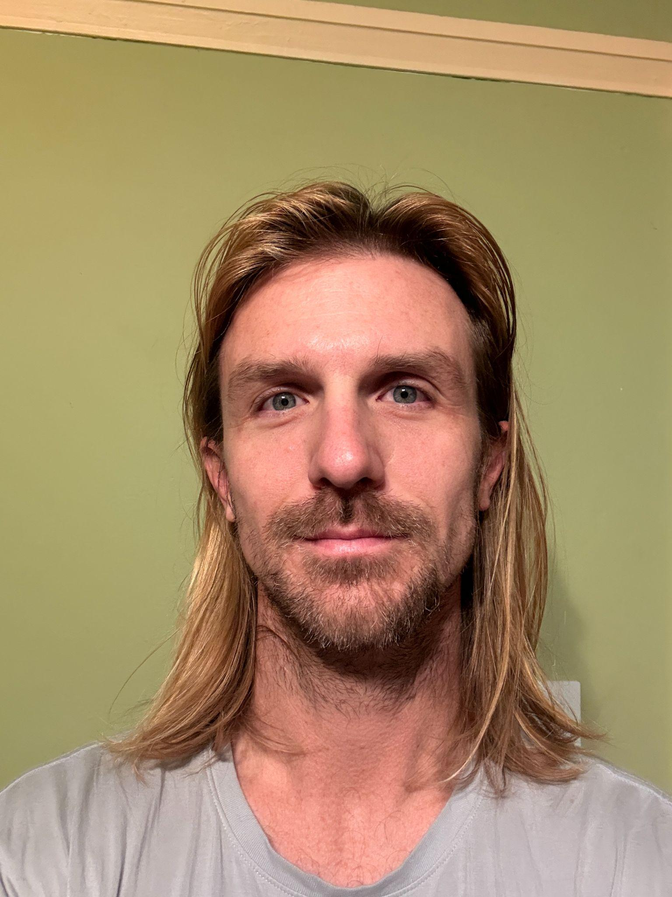 | 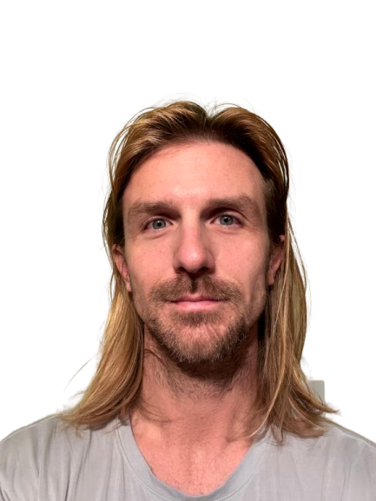 | 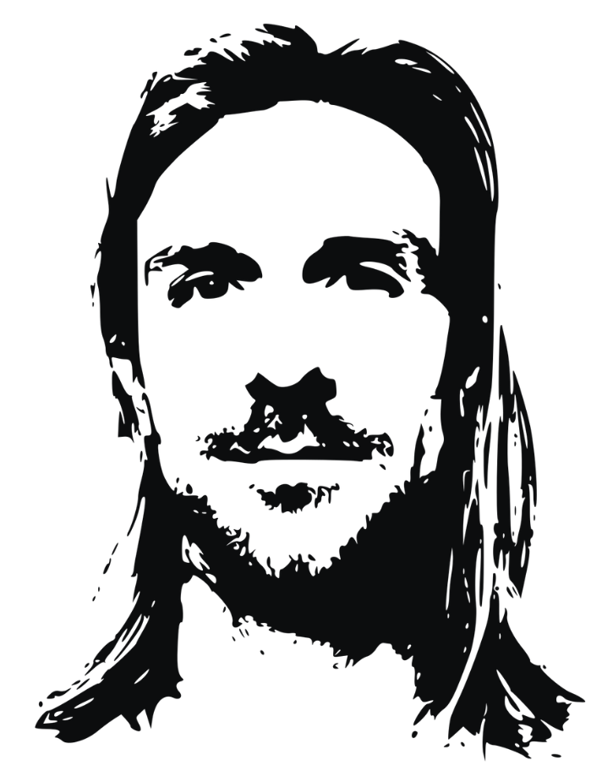 | 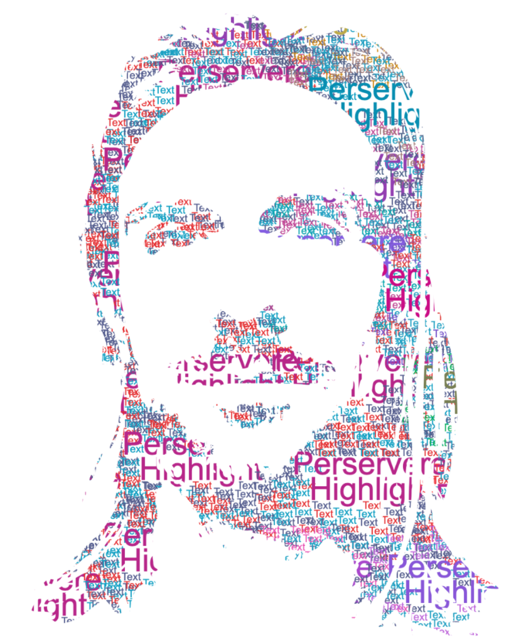

Final Finished Product
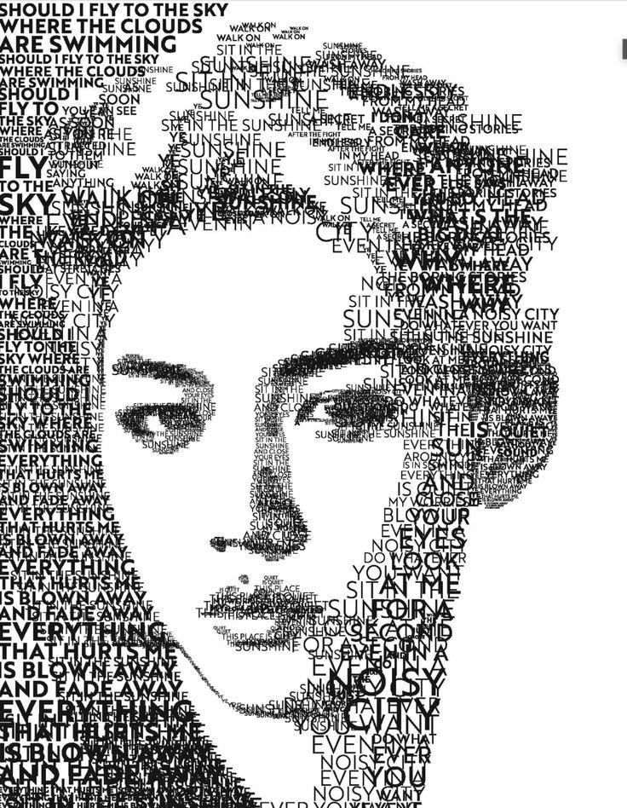 | 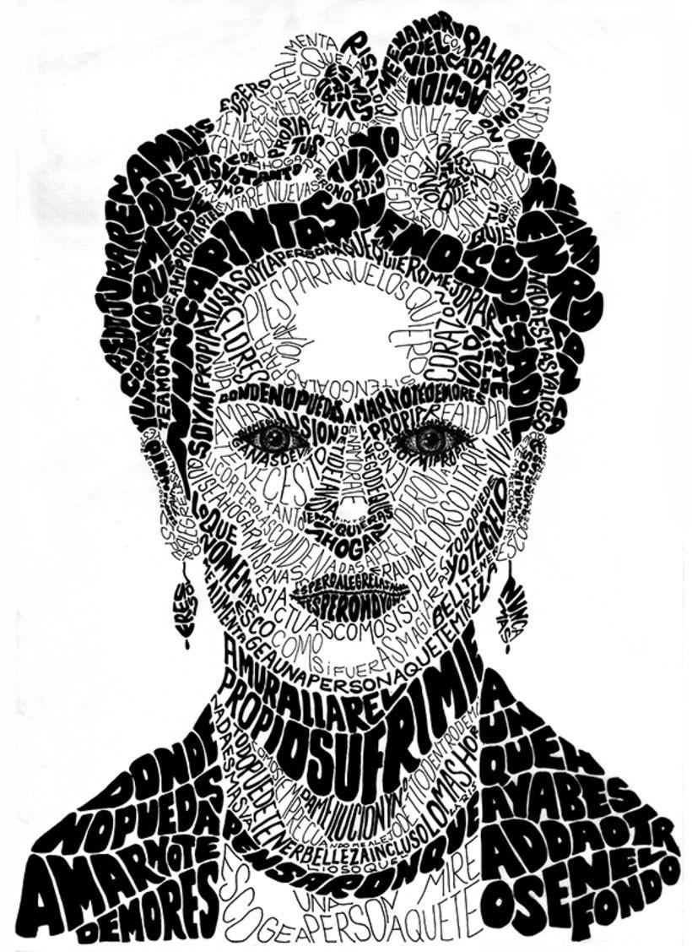 | 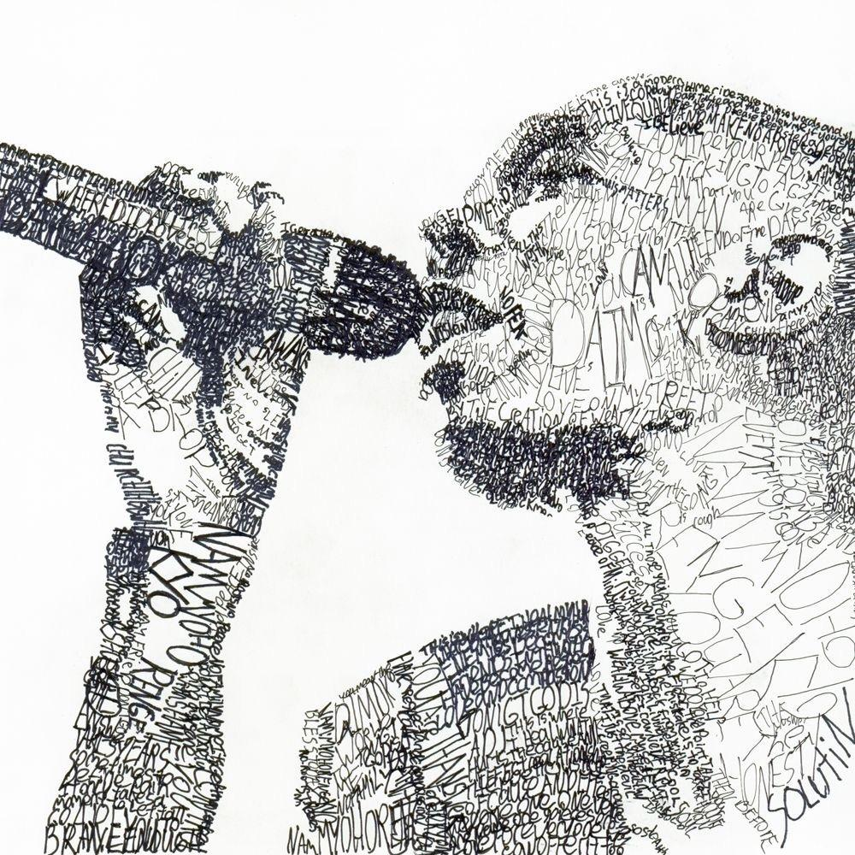

📌 Final Submission Checklist
- All drafting and revision done in class
- Written piece is between 500–750 words
- Final draft matches your in-class writing
- Visual self-portrait is meaningful, symbolic, and connected
- We’ll submit papers and portraits separately with the aim of merging all portraits into a single pdf that can print in one go.

❗Important Note About AI
This is your story. Your words. Your thinking.
Using AI to generate writing for this project defeats the purpose of everything we’ve built this year. It also won’t help you get better at expressing yourself—something you will need no matter where life takes you.
If I suspect AI use, I may ask you to redo the work from scratch. I want your authentic voice, not a polished fake.

✅ What You’ll Be Graded On
Category | What I’m Looking For
Traits & Values | Honest, thoughtful reflection on the significance of these values to your own life, what they look like IRL, or how you might embody them through action
Goals & Priorities | Clear goals, realistic plans, pragmatic strategies. The more specific the better.
Reader/Writer Identity | Real self-awareness about how you use and develop language
Written Quality | Organized, expressive, proofread
Visual Product | Symbolic, creative, clearly connected to written piece
Process | In-class drafting, one round of revision, effort across time

